rOBOTICS mORSE cODE aSSIGNMENT
Jessica Clara Fealy 18024092

Design and Implementation
This project has been completed by developing on both a physical and simulation robot that are both able to traverse and decode a morse code message using light sensors. The final submission for this project is the simulation of the EV3 robot.

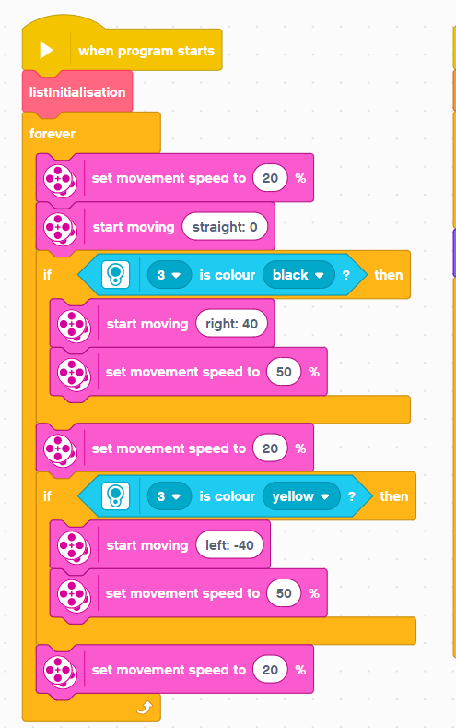
Physical design and implementation
Due to the physical robot being developed first more challenges were faced within this stage of development rather than when developing for the simulated robot. The initial challenged faced was ensuring the robot remained within the field parameters of the coloured bars on either side of the field; light sensors were used to determine what colour was being was beneath the robot, where the colour was black the robot motors would turn to the right, when the sensor no longer detected black the robot would turn left to face the rest of the passage. A similar approach was taken the colour beneath the robot was green, the robot would turn left until green was no longer detected, then the robot would turn right to face the rest of the passage. Doing these simple path corrections ensured that the robot would continue down the passage. This code is how the path corrections are performed.

For the robot to detect when a red pulse is either a dot or dash, or to detect whenever a white pulse was to signify a new separate dot or dash, a new character, or a new word; a pre-requisite task as needed to calculate the length of time in which the robot would be over a single dot. Whenever a robot detects red or white using the light sensors a counter would begin until the colour changed. With the speed being constant and the width of a single dot being constant, the resultant counter value when going over a single dot can be used to extrapolate the assumed counter value for all parameters. The following figures are used to determine what each colour block means With 20% and the known single line with value 299 some margin is given in these numbers to allow for some variations:
- Dot (single line) : 0 - 299
- Dash (triple line): 300 – infinite
- New morse character (single line) : 0 - 299
- New character (triple line) :
- New word (seven line) :
With the assumed numbers above provided conditional statements can be used to determine the action required when needed. When the sensor detects the colour red a counter will begin, this counter will stop when the colour changes to white. If the colour counter is equal to or less than the highest bound for a single line, then this red period is deemed to represent a dot. Using a list to store all morse inputs character a 0 is appended to this list. When the red counter is greater than the lowest bound for a triple line period then this red period is deemed to represent a dash and a 1 is appended to the morse input list.
When a white input is detected, a counter is started, this counter is ended when the colour detected changes to red. If when this happens the counter is equal to or lower than the highest bound for a single line it is assumed that a new morse character is to begin. When the counter is falls within the bounds for a triple line input then this is where the morse conversion occurs. Using a list of all alphabetical characters linked with these respective morse code representations, a linear search is preformed when a morse code representation is matched with the data from the morse code list then this alphabetical character is added to a string that represents the output of the morse message. Finally, when the counter is greater than the lower bound for the seven-line new word then the same stages are performed as if this was a new character, then a space character is added to the word that represents the morse message.
The code required to decode morse code can be found below as can the code required to initialise alphabet list.

Simulated design and implementation
The final submission for this assignment was committed using the Gear simulation of the robot, with the techniques and designs developed with the physical

Testing Strategy
The physical robot is limited in functionality and is only required to traverse down the morse code path and detect dots and dashes, with the information the robot is required to decode the signatures to limited known morse code dataset. As development for the physical robot was only intended to provide vital information and research for the final development of the simulation. Testing for the physical robot involved sending the robot over select morse code characters and display on screen if that was a dot or dash, this provided knowledge that the timings hard coded were correct. The final testing was committed by sending the robot over known morse code signatures as the robot was only programmed to be able to decode limited characters such as “ n “ and “ o “ the robot was first sent over morse that is known to mean either “ n “ or “ o “, with the robot returning the correct character, the robot is then sent over morse that does not represent “ n “ or “ o “ with no character being displayed – this was the expected outcome.
The testing required for the final development of the Gears simulation is more in-depth and extensive than the minor tests performed for the physical robot. The testing for the this development was done in stages, with each new functionality added further testing was done. Starting with the ensuring that the robot can traverse the environment and stop before the robot collides with the final wall, this was to test the code required for the motors to turn and to test the ultrasonic sensors ability to correctly stop the robot when x distance is detected between the sensor and the wall.
When the functionality for realigned were added tests were done to ensure that the robot would correctly realign and start along the correct path. For this testing to occur

Analysis and Discussion
Having developed the final morse code and with development being attempted on the physical I can see the differences between development on each style. Where with development on the physical robot each test will have different external factors that can affect the overall performance, with conditions in the room where the robot can impact the performance factors such as variations on lighting conditions or the position the test paper strip is placed affects the outcome of the physical robot. Whereas with developing on the Gears for the morse code robot provides a more consistent environment for testing with each rerun of the environment provides the same parameters each time. Gears attempts to slightly alter the environment (such as the starting angle of the robot) each time the environment is being run, these can be mitigated by restarting the environment until the conditions are ideal. While in real life controlling external factors can prove to be a challenge, in a simulation the environment can be customised with randomness introduced or reduced depending on the needed criteria. With testing on the physical robot being committed and data being retrieved from this testing I can see that the outcome of the simulation is accurate and representative of the expected results from the physical world.
TALK ABOUT CYBERNETICS AND VALIDATIONS OF SIMULATIONS
Physical development was preformed to test how to make the robot move and how to correctly associate colour detected with the respective action, through the primarily trial with the EV3 robot I was able to correct workout the process for calculating timings to associate each period these actions were duplicated into the simulation. Additionally, the physical robot only has a few characters with their morse code representations, the physical robot was used to test the detections and the correct allocation of detected morse code to the list of available morse code. When these tests provided fruitful with the logic of detecting limited morse code and their correct decoding on the physical robot further development was to be committed in the Gears simulation.

